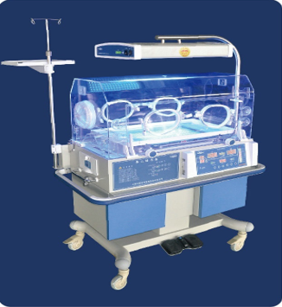y

**Temperature and humidity controller design**

**for incubator**

*Embedded Controlled System Design Instructor: Dr. Chu Duc Viet*

*Reporter: Pham Hoang Duong 20173789*

*Nguyen Tuan Hung 20176941*

*Vu Duc Phuc 20170145*

*Tran Bao Long 20171502*

**TABLE OF CONTENTS**

PART 1: REQUIREMENTS AND SPECIFICATIONS______4

1.1. Introduction_____________________________________4

1.2.Acknowledgement ________________________________5

PART 2: BLOCK DESIGN AND ELECTRICAL COMPONENTS SELECTION__________________________7

2.1. General bock diagram_____________________________7

2.2. Equipment selection_______________________________8

2.3. Calculation_____________________________________21

PART 3: SOFTWARE DESIGN_______________________40

3.1. Finite state model of user interface__________________40

3.2. Finite state model of unit control____________________42

3.3. Sequential program model_________________________44

REFERENCES_____________________________________46

**PART 1: REQUIREMENTS AND SPECIFICATIONS**

**1.1. Introduction**

**-** An incubator is designed to provide a safe, controlled space for infants to live while their vital organs develop. The system provides an environment that can be adjusted to provide the ideal temperature as well as the perfect amount of humidity and other factors namely light and oxygen.

- In the range of the report, our group mentioned the essential design for the temperature and humidity controller for the children incubator, which including the following criteria:

* Fundamental knowledge and the general structure performed by block diagram.
* Power supply designing.
* Electrical components and microprocessor selection.
* Software designing including user interface and control unit attached with brief algorithms.

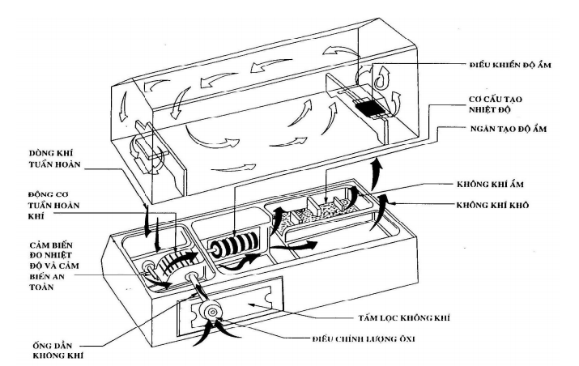

*Figure 1 : Newborn Incubator Model*

**1. 2. Acknowledgement**

**-** To achieve the requirement, we need to examine specifications of the system as a first step and using the specifications as a premise to analyze control theory, technical problems linked to electrical devices, microcontroller and programming.

**Specification Table**

|  |  |  |
| --- | --- | --- |
| *Criteria* | | *Value* |
| Size | | 920x430x685(mm) |
| Power Supply | | 220VAC- 50Hz |
| Power Consumption | | 300W |
| Input Voltage Range | | 3.3VDC - 12VDC |
| Input Type | Temperature | RTD |
| Humidity | Analog |
| Output Type | Temperature | Relay SSR |
| Humidity | Servo Motor |
| Temperature Range | | 25-38 $°$ C |
| Humidity Range | | 40% -85% |
| Sampling time | | 30s |
| Display method | | LCD |

**PART 2: BLOCK DESIGN AND ELECTRICAL COMPONENTS SELECTION**

**2.1. General block diagram**

*Figure 2 : Block Diagram*

In the domain of the project, our group pays attention into controller design, based on the specifications as mentioned above, we have main blocks consist of input block, power supply block and output block.

Power supply provides voltage for the system from varieties range of input, output and controller.

**2.2. Equipment selection**

**2.2.1. Input devices**

**2.2.1.1 Temperature measurement**

- Requirement:

**+** The device requires to detect temperaturewith small deviation.

+ The temperature range of the required incubator is 25 – 37 degree Celsius.

+ The error is very small.

Choose: RTD (Pt100, Pt1000, Cu50, Ni100…), Thermocouple (K, J, E...)

* The Pt100 temperature sensor is easy to use, compatible with most temperature readers and controllers. High purity platinum helps to increase the accuracy of resistance properties. Furthermore, chemically inert and crystalline stability allows good performance over a wide temperature range. There is also high repeatability, low random error (less than 0.01%).
* Cu50 sensors are uncommon in industry and are not suitable for working in environments with high oxidation and humidity.
* Ni100: Nickel is more sensitive than platium but highly chemically susceptible to oxidation when the temperature increases so the working temperature range is limited.
* Thermocouple K suitable for high temperature regulation in oxidizing environments but not used in atmospheric environments. Its range is from –270°C to +1372°C. The error is ±1.1 $°C$.
* Thermocouple J include an iron anode and a cathode (copper - nickel alloy). Specified to measure the average temperature in atmospheric reduction. However, the iron content is easily damaged by oxidation in high humidity environments.
* Thermocouple E measure temperatures from -270ºC - 870ºC. Recommended for oxidizing environment. Error of thermocouple E is ± 1.7°C.

So, Pt100 3 wires is appropriate for the requirement because:

* Can measure a wide range of temperature.
  + Common measuring range: -200 – 800 degree Celsius (suitable for the problem)
* The deviation is in the vicinity of 0.15 degree Celsius for class A and 0.3 degree Celsius for class B.
* Not easily corroded.
* Three types of Pt100 sensor: 2 wires, 3 wires, 4 wires…. The more wires the more
* Accurate the sensor measures

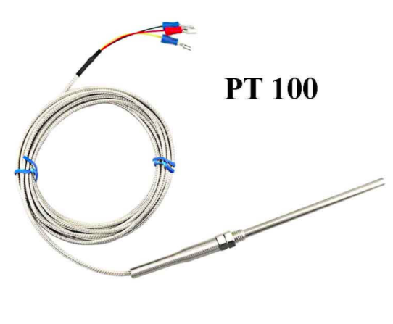

*Figure 3: Pt100 3 wires sensor*

- PT100 is a thermistor sensor. We need to receive signals from PT100 to Microcontroller to process; therefore, IC Max31865, which is an RTD-to-Digital converter, is used to convert the signal from Pt100 to microcontroller. The MAX31865 circuit amplifies and converts the signal from Platinum RTD sensors such as PT100 / PT1000 to Digital with SPI interface for easy communication with the Microcontroller.

* Using IC RTD to Digital MAX31865

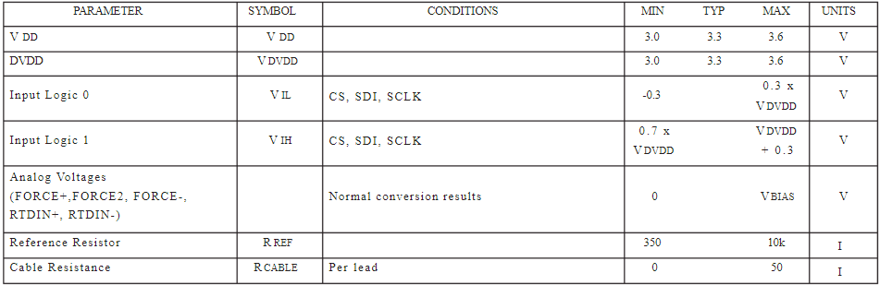

* Operating voltage 3 ~ 5VDC
* Power supply current 2-3.5mA
* Communication voltage 3 ~ 5VDC
* Communication standard: SPI
* Suitable for RTD sensors: PT100 / PT1000, ...

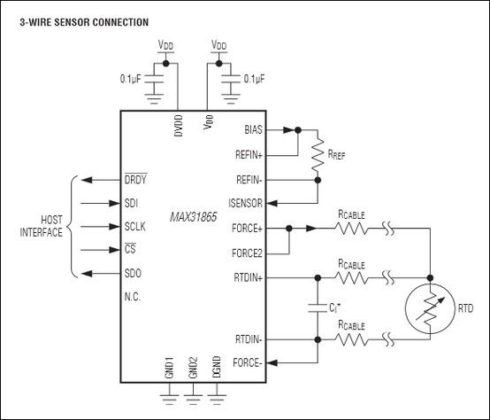

*Figure 4: Max31865 RTD to Digital converter*

**2.2.1.2.Humidity measurement**

- Requirements: Sensor used in industry, with little error because of application in the medical field. Withstands temperatures below 100 degrees C and has a large measuring range.

- Several types of sensors are suitable for requirements: SHT30-HT533, HYT 221, HS 1101.

- Compare:

* Temperature and humidity sensor SHT30 HT533 is used to measure temperature and humidity with standard I2C interface which is easy to connect and communicate with the microcontroller, PE waterproof housing is made of polymer material, resistant to dust, waterproof, good ventilation. The sensor is composed of sensor SHT30 inside, outside is the cover protecting the sensor from physical impacts from the environment such as dust, water ...

The wire of the SHT30 HT533 temperature and humidity sensor uses pure copper PVC cable, low resistance, voltage stability, wear resistance, softness and fire resistance. Sensors are commonly used in agricultural greenhouses, high humidity environments, outdoors and most types of environments, can check soil air humidity, water diffusion.

However, large humidity error (±3%). Not suitable for use in the hospital.

* HYT 221 is a digital output sensor that can connect to a microcontroller using I2C communication, with high accuracy (1.8%). Suitable for use in medium temperature environments (<100 degrees C) wide measuring range and durable under ideal environments such as incubators.
* HS1101 is durable in industry and withstands high temperatures, commonly used, large measuring range, small error (< 2%). However, the output is analog, so an additional ADC port is required.

- The device uses HYT221 humidity sensor:

* Operating voltage 2.7V – 5.5V
* Current consumption: < 22uA at 1Hz measuring rate, 850uA maximum.
* Sleep current consumption: < 1uA.
* Digital interface: I2C
* Limit voltage: -0.3 – 6.0V
* I2C-compatible interface: 100 kHz and 400 kHz

which has benefits:

* The measurement range of 0 to 100% RH
* Accuracy within 1.8%
* Splash waterproof with protection filter
* Dew formation resistant

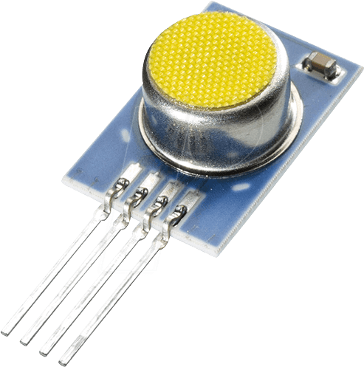

*Figure 5: HYT221 humidity sensor*

*converter*

**2.2.2. Output devices**

**2.2.2.1 Relay**

- Requirements: Relay has high switching speed, energy saving, no "tach" sound during operation, no ignition.

- Choose:

* Electromagnetic relay is capable of switching with high voltage but does not meet the requirements.
* Instead of using conventional relay, solid state relay is suitable for this project because:
* Fast switching speed.
* Require low power consumption to energize.
* Mitigate the noise and ability to generate electric sparks in comparison to conventional relay.

- To control the temperature, we control the heating capacity of the heating rod by using the SSR Semiconductor Relay connected to the Microcontroller.

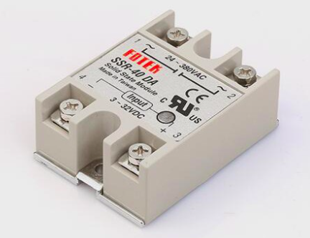

*Figure 6 : Solid state relay*

*r*

*converter*

* Choose: FUTEK SSR-40DA suitable for the voltage range used and required, easy to install, cheap, common.
* Technical parameters:
* Input voltage: 3-32 VDC.
* Input current: 75mA (12V).
* Output voltage: 24V-380 VAC.
* Max output current: 40A.

**2.2.2.2. Motor**

- Requirements: Motor has extremely high precision, does not need to respond too quickly, is able to communicate with microcontrollers to accurately control the position, less energy consumption.

- Choose: Some motor types: Step motor, Servo motor

* Step motor:

- Stepper motor can precisely control the angle of rotation.

- Compared with servomotor, stepper motor has much lower cost

- Stepper motor operates stably, durable, long service life

- Stepper motors can be easily installed and replaced

- The stepper motor is capable of delivering large torque in the medium and low speed range

- Basically, the current from the driver to the motor winding cannot be increased or decreased during operation. Therefore, if overloaded, the motor will slip and cause error in the control.

- The stepper motor causes a lot of noise and vibration

* Servo motor:

- If the load applied to the motor increases, the controller would increase the current to the motor winding to keep spinning. Avoid sliding step as in stepper motors.

- Can be operated at high speed.

- Servo motor has a higher cost than stepper motor.

- When stopped, the servomotor usually vibrates at the stop position causing vibrations.

So, servo motor MG996R is appropriate because:

* Wide opening angle: 120 degrees
* Operation speed: 0.17sec/60 degrees at 5V
* Torque: 9.4 kgf.cm at 5V

- To control the humidity in the incubator, we control the air circulation slot. We use MG966R servo, with high speed and precision to do that.

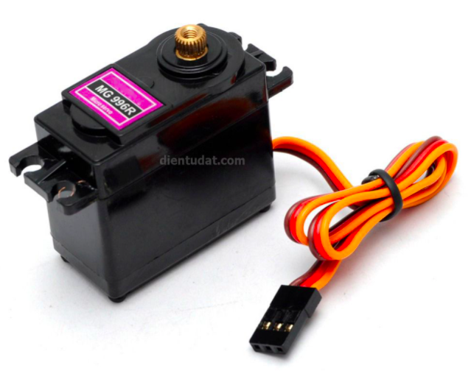

*Figure 7 : Servo motor MG996R*

*r*

*converter*

* Operating voltage: 4.8V to 7.2V
* Running current: 500mA – 900mA
* Stall current: 2.5A

**2.2.2.3. Display**

**-** The information that are required for the user are the temperature and the humidity in the incubator in real time. As a result, we chose LCD1602 to present the information with line 1 for temperature and line 2 for humidity.

- The microcontroller connects with LCD via module PCF8574 which using I2C communication standard to transfer data.

- PCF8574 connects with 16 pins of LCD, so by using PCF8574, we can save the number of pins for microcontroller.

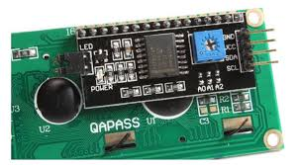

*Figure 8: Serial LCD I2C Module- PCF8574*

**2.2.2.4. Alarm**

* Requirements: The alarm system when an incident is not too big to ensure that babies are not affected while in the cage, but not too small for doctors to detect in time.
* Some suitable equipment: Piezoelectric buzzer, buzzer 12850.
* Buzzer 12850

- Rated voltage: 1.5V

- Rated current: <= 30mA

- Output amplitude: 85dB

- Sound frequency: 2048 Hz = 2KHz

- Working temperature: -20°C to 45°C

* Piezoelectric buzzer

- Source: 3.5V - 5.5V

- Current consumption: < 25mA

- Resonance frequency: 2300Hz ± 500Hz

- Sound amplitude:> 80 dB

- Operating temperature: -20°C to +70°C

- So, choose Piezoelectric buzzer because there is no device in the circuit whose voltage range matches Buzzer 12850

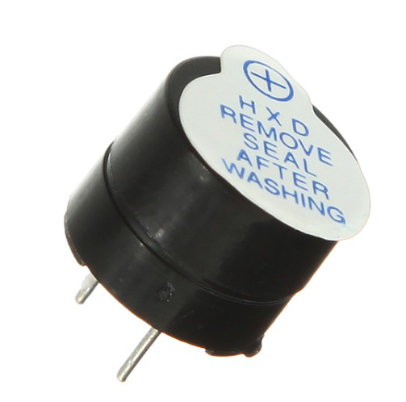

*Figure 9 : Piezoelectric buzzer*

*r*

*converter*

**2.2.3. Other components selection**

**2.2.3.1. Isolated component**

- Insulation components are used to isolate sources and equipment to avoid damage to important components in case of an incident. Some types of isolators are commonly used in industry such as opto, transformer… but transformer just only used in AC circuit.

* Some opto in industry:

Opto-coupler uses Photo Transistor (**PC816, PC817, LTV817, K847PH**)

Opto-coupler uses Photo Darlington transistor (**4N32, 4N33, H21B1, H21B2, H21B3)**

Opto-coupler uses Photo TRIAC (**IL420 , 4N35)**

Opto-coupler uses Photo SCR (**MOC3071, IL400, MOC3072)**

Choose opto has cheap, easy to buy and replace, have CTR more than 30%, low cost.

$→$ Select opto PC817.

$I_{F}$ = 50mA, $I_{c}$ = 50mA, CTR=100 $×\frac{I_{c}}{I_{F}}=100\%$

Peak forward current = 1A

Reverse voltage = 6V

Collector-emitter voltage = 80V

Emitter-collector voltage = 6V

Temperature: -30 ~ 100 degrees C

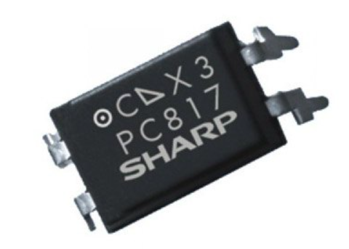

**2.2.3.2. Bipolar junction transistor**

-BJT selected must have current Ic > I need and suitable voltage, cheap and high switching speed, cheap and popular

- Choose C1815 NPN BJT

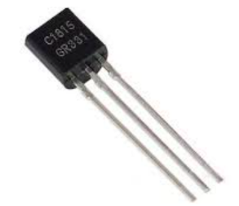

*Figure 10 : BJT*

*r*

*converter*

**2.2.3.3. Terminal block**

* Terminal Block is a connector that allows multiple circuits to be interconnected use in industry.
* Requirements: terminal block use in industry, rate power 220VAC-300W, cheap and suitable for circuit, high stability.
* Some popular Terminal Block:

+ Togi's PT series terminal: Products are available in voltage ranges from 15A to 600A. - Terminal PT products range from 22A to 600A, suitable for all wire sizes (from 2mm2 to 325mm2). Even when the power capacities are different, the user can mount blocks of devices on the same stick.

+ TE-010 Din Rail Mounted Assembly Type 600V 10A Terminal Strip. The Rated Voltage of our TE-010 Terminal Strip is 600V, and the Rated Current is 10A. About TE-010 Terminal Block, it can be assembled into Multi Pole.

For example: "TE-010-09P" is 9 Pole Terminal Block.

* Rated Voltage: 600V
* Rated Current: 10A,
* Wire Size: 1.6 mm2

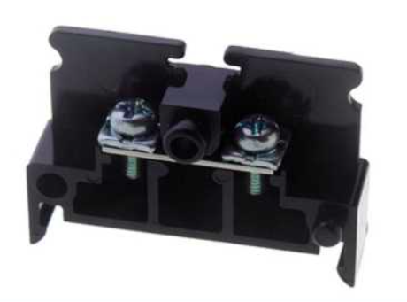

*Figure 11 : Terminal Block*

*r*

*converter*

**2.2.3.4. Button**

In order to serve the most convenient experiences for users, which easier to do set functions we decided to select the push button instead of hold button.

We use R13-507 which has multiple choice of color to distinguish.

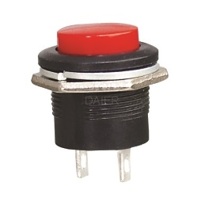

*Figure 12 : Push button*

*r*

*converter*

**2.2.4. Microcontroller selecting**

As following the schematic , our group choose a microcontroller which should be compatible with criteria as mentioned below:

* Must have at least 20 pins to connect to sources and peripherals.
* Must have 1 SPI and 2 I2C interface types built-in microcontroller.
* Signal processing speed must be high and accurate.

Following this requirements, the appropriate microcontroller used for the system is STM32F103C8T6.

In addition to the satisfaction of the system, microcontroller STM32F103C8T6 is also contained particular advantages as:

* Small size and low price( $1.99)
* RAM 20kBytes and Flash 128kBytes
* Maximum frequency: 72MHz
* Comfortable to buy and uncomplicated programming.

**2.3. Calculation**

**2.3.1. Power supply**

AC-DC rectifier 220VAC-12VDC supply for SSR MG996R and provide 12V as input to other converters.

**2.3.1.1. Choose components for power supply.**

Need 12VDC voltage supply to relay input SSR-40DA.

* SSR-40DA has:

Input voltage: 3-32VDC $→$ choose 12VDC.

Input current: 75mA (12VDC)

Some voltage stepdown IC 12VDC: LM2576-12V, LM7812…

* Transformer 220VAC - 12VAC-5A lowers the voltage from the grid.
* Diode bridge RS507 has:

Maximum reverse voltage: 1000V

Maximum forward current: 5A

Forward voltage drops: 1V.

Reverse current: 500uA

Operating temperature range: -55°C ~ 150°C.

* LM7812:

Input voltage: $V_{in}=12\sqrt{2}-1=15.79 VDC$ (drop voltage on bridge diode)

Output voltage: $V_{o}=11.5V→12.5V$

Output current: $I_{o}=5mA→1.5A (nomally 1A)$

* Choose Fuse 0.4A: When output current of secondary coil equal 5A, the peak current of primary coil $I_{1}=\frac{12×5}{220}×\sqrt{2}=0.38A$
* Choose capacitor 1000uF/50V to electric flattening.

0.1uF/50V to decrease ripple input voltage.

10uF/35V to low frequency noise filter

0.01uF/35V to high frequency noise filter

$→$ Suitable for SSR.

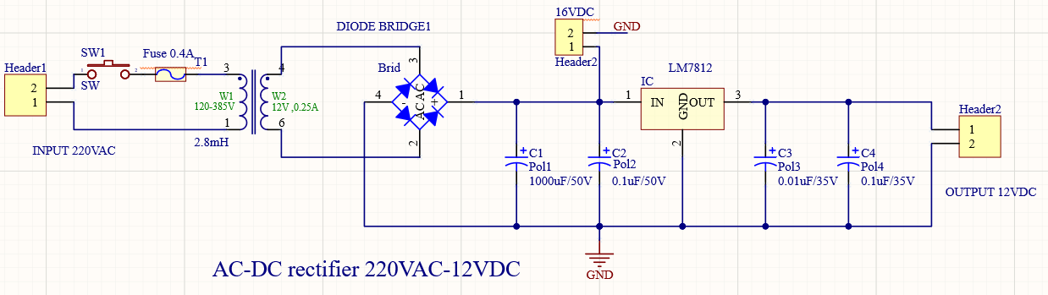

16VDC voltage is taken out after being rectified across the diode bridge and flattened by the source capacitor.

DC-DC converter 16VDC-5VDC supply for servo motor MG996R, Piezoelectric buzzer, PCF8574, LCD, 3 output optos and supply for 3.3VDC circuit.

* Select LM7805, LM2576T5.0, LM2596T5.0… 7805 is a linear IC that reduces pressure by radiating so it is not recommended to choose the voltage difference too large in addition 7805 only gives a maximum current of 1.5V, not enough power to supply the source, and LM2576T5.0, LM2596T5.0 3A and buck type pressure reducer.
* Servo motor MG996R has:

Operating voltage: 4.8V to 7.2V

Running current: 500mA – 900mA

Stall current: 2.5A

* Piezoelectric buzzer has:

Source: 3.5V - 5.5V

Current consumption: < 25mA

* PCF8574 has:

Supply voltage: 2.5V to 6VDC

Supply current: 40uA.

Maximum supply current: 100mA

* LCD has:

Operating Voltage is 4.7V to 5.3V

Current consumption is 1mA without backlight.

* PC817 has:

$I_{c}$ = 50mA

So, the maximum supply current in circuit using 5VDC:

$$I_{max}=2.5A+25mA+100mA+1mA+3*50mA+0.134A(5 to 3.3VDC circuit)=2.796(A)$$

* LM2576 is a source IC integrated pulse source circuit according to the principle of buck circuit. The output voltage is always adjusted continuously so that the output voltage is always constant.

pin 1 is the input source.

pin 2 is the output voltage.

pin 3 is GND.

pin 4 is the pin of the output voltage to compare and regulate stability.

pin 5 is the ON / OFF pin that will normally be connected to GND.

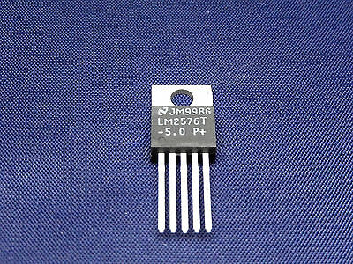

*Figure 12 : LM2576T-5.0*

*r*

*converter*

* LM2576T-5.0 has:

Input voltage: 8VDC – 40VDC

Current consumption: 0.5A-3A

Switching frequency: 52kHz

Feedback current: 50nA typical at 25°C

On/Off pin input voltage: -0.3 < V< +Vin

Operating temperature range: -40°C to 125°C

* Choose inductor L1:

The inductor chosen must be rated for operation at the LM2576 switching frequency (52 kHz) and for a current rating of 1.15 x I load by the formular:

$$E*T=\left(V_{in}-V_{out}\right)×\frac{V_{out}}{V_{in}}×\frac{1000}{F} (V*uS)$$

Then, select the maximum load current in horizontal axis and select E*T in vertical axis in reference figure in the datasheet.

$$E*T=\left(16-5\right)×\frac{5}{16}×\frac{1000}{52}=66.1 (V*uS)$$

$$and I_{max}=3A$$

So, choose L100 is L1 = 100uH

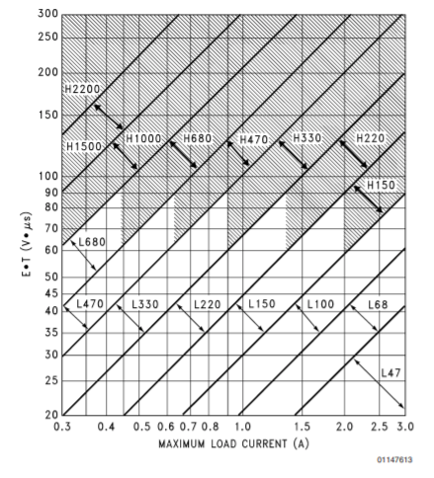

* Output Capacitor Selection (Cout) The value of

the output capacitor together with the inductor defined.

the dominate pole-pair of the switching regulator loop.

For stable operation, the capacitor must satisfy the

following requirement:

$$C_{out}≥13,300×\frac{V_{in}max}{V_{out}×L\left(uH\right)} (uF)$$

The above formula will satisfy the loop requirements for

stable operation. But to achieve an acceptable output ripple voltage, (approximately 1% of the output voltage) and transient response, the output capacitor may need to be several times larger than the above formula. The capacitor's voltage rating should be at last 1.5 times greater than the output voltage.

$$C_{out}≥13,300×\frac{16}{5×100\left(uH\right)}=425.6 (uF)$$

So, choose $C_{out}=1000uF$

* Choose catch diode (D1). The catch-diode

current rating must be at least 1.2 times greater than the maximum load current. Also, if the power supply design must withstand a continuous output short, the diode should have a current rating equal to the maximum current limit of the LM2576. The most stressful condition for this diode is an overload or shorted output. The reverse voltage rating of the diode should be at least 1.25 times the maximum input voltage.

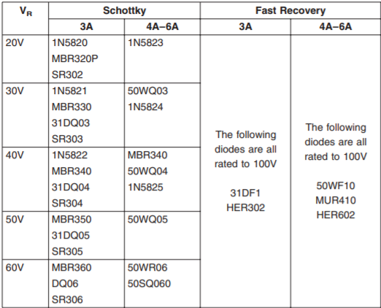

*Recommend for diode in datasheet of LM2576.*

Vr < 20V and maximum load current is 3A. So, choose 1N5820 Schottky diode.

* Input Capacitor (CIN) A 100 µF aluminum electrolytic capacitor located near the input and ground pins provides sufficient bypassing. And ignore ripple voltage.
* Fuse to protect the converter circuit when.

$$I_{load}>3A→I_{in}=\frac{3×5}{16}=0.9375(A)$$

So, choose fuse 1A.

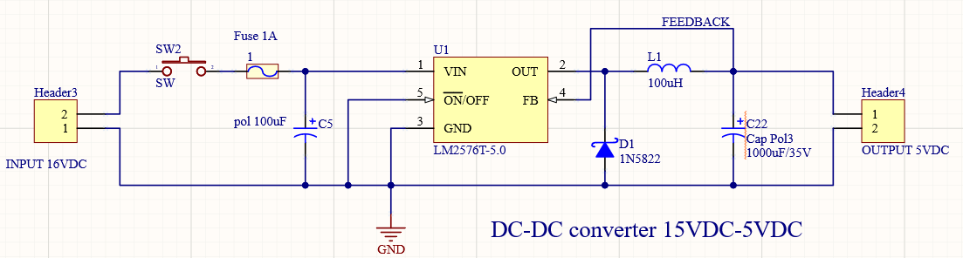

DC-DC converter 16VDC-3.3VDC supply for oppto PC817, pull-up and active for HYT 221, power supply for MAX31865 and other devides.

PC817 has $I_{F}$ = 50mA

MAX31865 has power supply current 2-3.5mA

HYT 221 has 850uA maximum

Button has 33mA

So, maximum current consumption = 87.35mA

* Select TPS54540 has:

Input voltage: -0.3V to 45V

FB voltage: -0.3 to 3V

Output voltage: 0.8 to 44.1V

Output current 5A

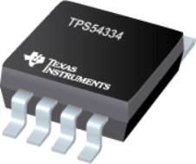

* The first step is to choose a switching frequency for the regulator.

$$f_{sw}(\max{skip)=}\frac{1}{t_{on}}(\frac{I_{0}×R_{DC}+V_{out}+V_{d}}{V_{in}-I_{0}×R_{DS(on)}+V_{d}})$$

$$f_{sw}(\operatorname{shift}{)=}\frac{f_{DIV}}{t_{on}}(\frac{I_{CL}×R_{DC}+V_{out(sc)}+V_{d}}{V_{in}-I_{CL}×R_{DS(on)}+V_{d}})$$

Io = Output current = 5A

ICL = Current limit = 6.3A

Rdc = inductor resistance = 10.3mΩ

VIN = maximum input voltage = 42V

VOUT = output voltage = 3.3V

VOUTSC = output voltage during short = 0.1V

Vd = diode voltage drop = 0.52V

Rds (on) = switch on resistance = 92mΩ

tON = controllable on time = 135ns

ƒDIV = frequency divide equals (1, 2, 4, or 8) = 8

$$f_{sw}(\max{skip)=}680kHz$$

$$f_{sw}\left(shift\right)=960kHz$$

For this design, a lower switching frequency of 400 kHz is chosen to operate comfortably below the calculated maximums.

RT = $\frac{101756}{{f_{sw}(kHz)}^{1.008}}=242kΩ$

* To calculate the minimum value of the output inductor

$$L_{o}min=\frac{V_{IN}\left(max\right)-V_{out}}{I_{out}×K_{ind}}×\frac{V_{o}}{V_{in}×f_{sw}}=5.1uH$$

Choose inductor 5.5uH

* The output capacitor determines the modulator pole, the output voltage ripple, and how the regulator responds to a large change in load current. The output capacitance must be selected based on the most stringent of these three criteria. The desired response to a large change in the load current is the first criteria. The output capacitor needs to supply the increased load current until the regulator responds to the load step
$$C_{o}=\frac{{2×∆I}_{out}}{f_{sw}×{∆V}_{out}}=\frac{2×2.5}{400kHz×0.13}=95uF$$

* Catch diode

The TPS54540 device requires an external catch diode between the SW pin and GND. The selected diode must

have a reverse voltage rating equal to or greater than VIN (max). The peak current rating of the diode must be

greater than the maximum inductor current. Schottky diodes are typically a good choice for the catch diode due

to their low forward voltage. The lower the forward voltage of the diode, the higher the efficiency of the regulator.

$$I_{D}=\left(1-\frac{V_{out}}{V_{in}}\right)×I_{load}=2.38(A)$$

So, choose Schottky diode 1N5822 has:

Maximum DC voltage input: 40V

Maximum average forward current: 3A

Maximum peak reverse voltage: 40V

* Filtering for 3.3V input:  
  A 47uF capacitor for low pass filter, and a group of 0.1uF as high pass filter
* The undervoltage lockout (UVLO) can be adjusted using an external voltage divider on the EN pin of the TPS54540-Q1device. The UVLO has two thresholds, one for power-up when the input voltage is rising and one for power-down or brown outs when the input voltage is falling.
$$R_{UVLO1}=\frac{V_{START}-V_{STOP}}{I_{HYS}}=\frac{5.75-4.5}{3.4uA}=365kΩ$$

$$R_{UVLO2}=\frac{V_{ENA}}{\frac{V_{START}-V_{ENA}}{R_{UVLO1}}+I_{1}}=\frac{1.2}{\frac{5.75-1.2}{365kΩ}+1.2uA}=88.7kΩ$$

* Output Voltage and Feedback Resistors Selection

The voltage divider of RHS and RLS sets the output voltage. For the example design, 10.2kΩ was selected for RLS.

$$R_{HS}=R_{LS}×\frac{V_{out}-0.8}{0.8}=31.9kΩ$$

$R_{15}=17kΩ recommend in datasheet$

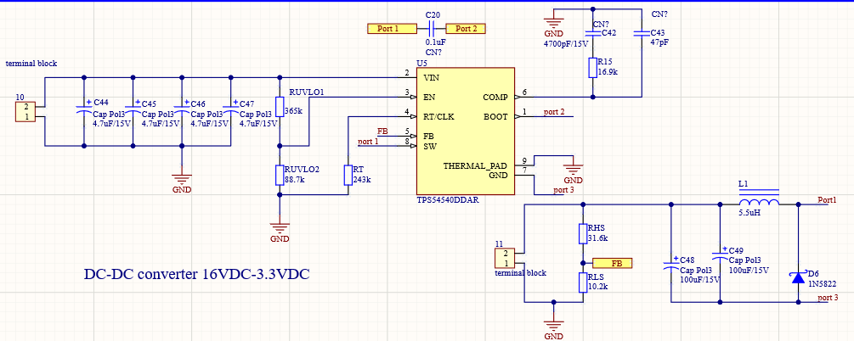

DC-DC converter 5VDC-3.3VDC supply for MCU

5VDC from DC-DC 16VDC-5VDC provided for this power supply.

* STM32F103C8T6 has:

Operating voltage 2V – 3.6V choose 3.3VDC

Maximum current consumption: 150mA

So, the maximum supply current in circuit using 3.3VDC:

$$I_{max}=150mA=0.150(A)$$

* Maximum supply current input = $\frac{3.3×0.15}{5}×134\%=0.134(A)$
* Choose LM1117-3.3v voltage regulator IC is used to stabilize the 3.3v output voltage, with the maximum input of 9v and the minimum 5v.

LM1117-3.3V has:

Input voltage: 4.5VDC to 9VDC

Output voltage: 3.235V-3.365VDC

Output current: 10mA-800mA.

* Choose input Bypass Capacitor.

An input capacitor is recommended in datasheet. A 10µF tantalum on the

input is a suitable input bypassing for almost all applications.

So, choose 10µF/15V.

* The output capacitor is critical in maintaining regulator stability and must meet the required conditions for both minimum amount of capacitance and ESR (Equivalent Series Resistance). The minimum output capacitance required by the LM1117 is 10µF if a tantalum capacitor is used.

So, choose 10µF/15V.

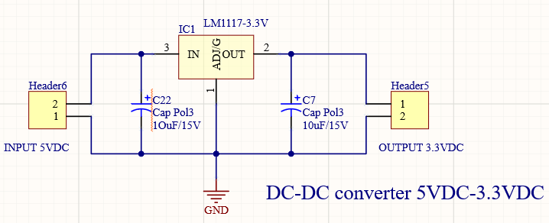

**2.3.2. Input**

* To measure the temperature, we use RTD PT100 sensor and MAX31865 to read data from PT100 and convert analog signal to digital signal.
* Max31865 has:

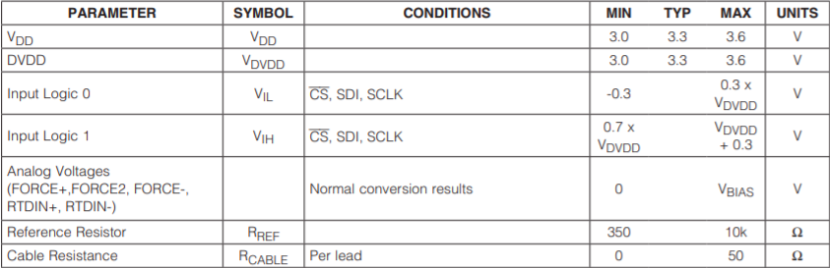

* Choose R_ref = 1kΩ
* Ci = 10nF for 1kΩ RTD and 100nF for 100Ω RTD (recommend)
* 3.3VDC to VDD and VDVDD
* 2 capacitors C1=C2= 0.1uF (high pass filter)

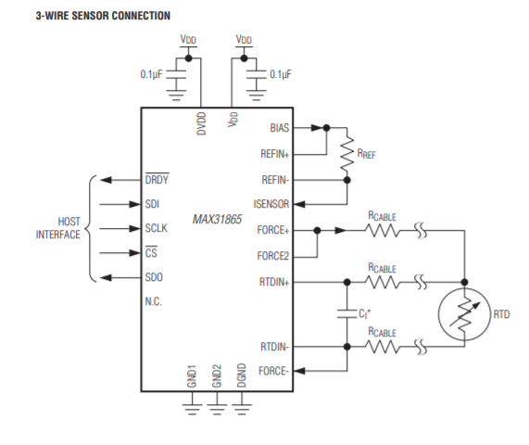

*Recommend circuit in datasheet with RTD 3 wires.*

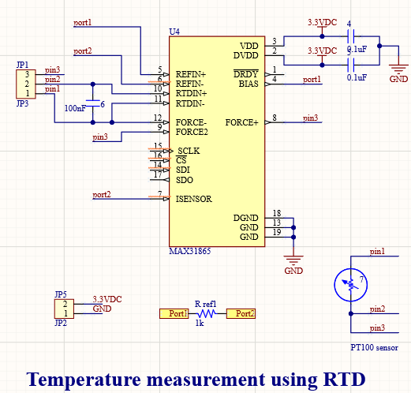

* To measure humidity, we use HYT 221 sensor and need 3.3VDC to pull-up for this circuit.

SCL and SDA are always pulled up with a pull-up resistor of approximately 4.7 KΩ (depending on the device and communication standard, can fluctuate between 1KΩ and 4.7kΩ).

* Appropriate return value of pull up should ensure 2 factors:

Match logic level matching: Rp (min)

Ensuring the rise time of the signal: Rp (max)

* In order for the IC (microcontroller or processor) to properly recognize the logic, the pin voltage must be greater than VOL (the highest voltage at LOW). We have the formula for the minimum resistance min as follows:
$$R_{p}min=\frac{V_{cc}-V_{OL}max}{I_{OL}}$$

$$V_{IH}=0.7×V_{cc}=V_{cc}\left(1-e^{\frac{-t1}{R_{p}×C_{b}}}\right)$$

$$V_{IL}=0.3×V_{cc}=V_{cc}\left(1-e^{\frac{-t2}{R_{p}×C_{b}}}\right)$$

$$t1=0.3566749×RC$$

$$t2=1.2039729×RC$$

$$t_{r}=t2-t1=0.8473×R_{p}×C_{b}$$

$$R_{p}max=\frac{t_{r}}{{0.8473*C}_{b}}$$

* The humidity module HYT 221 has:

Operating voltage 2.7V – 5.5V > 2V $→V_{OL}=0.4VDC and I_{OL}=3mA$

Current consumption: < 22uA at 1Hz measuring rate, 850uA maximum.

Sleep current consumption: < 1uA.

Digital interface: I2C

Limit voltage: -0.3 – 6.0V

I2C-compatible interface: 100 kHz and 400 kHz

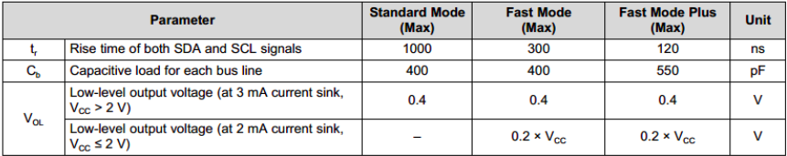

*Recommend in datasheet.*

$$R_{p}min=\frac{3.3-0.4}{0.003}=966.667Ω$$

$$R_{p}max=\frac{1000}{0.8473×400}=2.95kΩ$$

* So, choose pull-up resistors for I2C: $R_{p}=2.2kΩ$

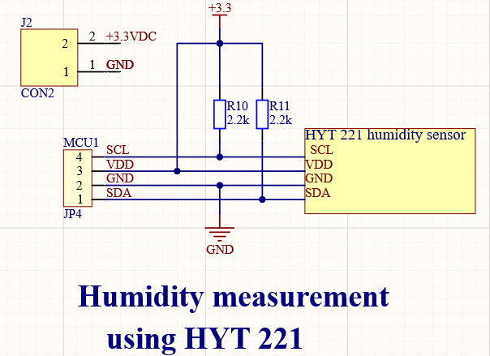

**2.3.3. Output**

* Relay SSR to on/off 220VAC circuit contain heat generator to control temperature.
* So
* C1815 NPN BJT
* Opto PC817
* Choose $Rssr =\frac{12-0.7}{0.075}=150$ Ω so choose Rssr = 220Ω
* Choose R22 = $\frac{5}{50×{10}^{-3}}=100Ω$ choose R22 = 220 $Ω$
* Choose R18 = $\frac{3.3-0.7}{25×{10}^{-3}}=104Ω$ choose R18 = 220 $Ω$

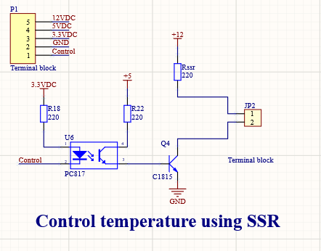

* Control open valve percentage to control humidity air go through the cage.

Operating voltage: 4.8V to 7.2V

Running current: 500mA – 900mA

Stall current: 2.5A

* Choose C1815.
* Choose PC817.
* Choose R31=R32=R12=R13 = $220Ω$ the same with SSR circuit

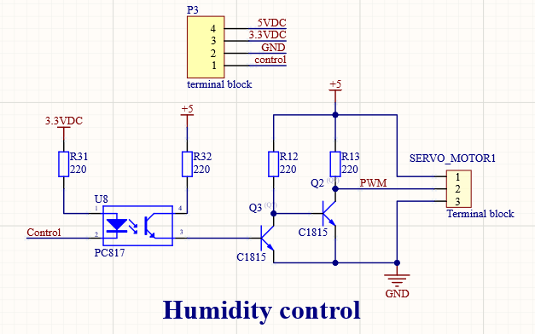

**2.3.4. Display and communication system.**

- As recommended in the datasheet, the range resistor in pin VEE is 10k-20k $Ω$, Pull-up resistor is calculated in the previous part.

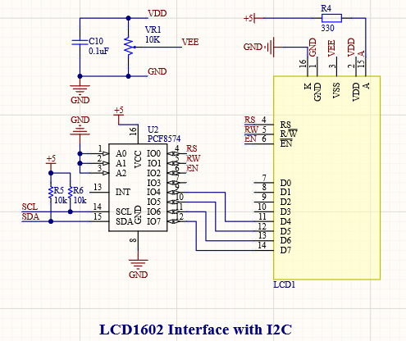

**2.3.5. Alarm**

- Piezoelectric buzzer has:

* Source: 5V
* Current consumption: < 25mA

Calculate:

* R17= $\frac{5}{25×{10}^{-3}}=200Ω$ choose R17=R14=19=220 $Ω$
* C1815
* PC817

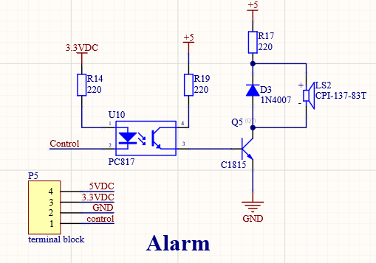

**2.3.6. Button and reset.**

- The microcontroller has:

* Max input current for pins: 5mA
* R45 = R46 =R47 = R48 = R49 = $\frac{3.3-2}{5x10e-3}$ = 260 $Ω$
* Choose R = 220 $Ω$, Capacitor C = 10uF

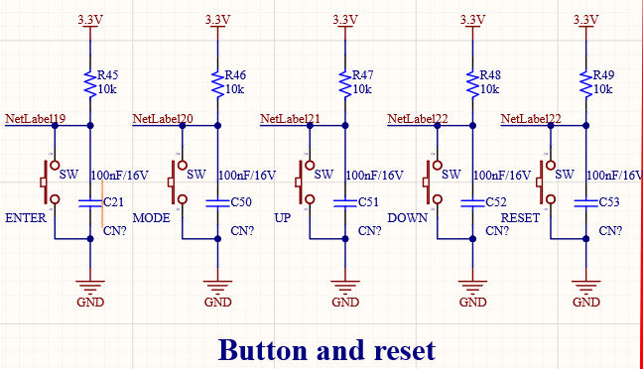

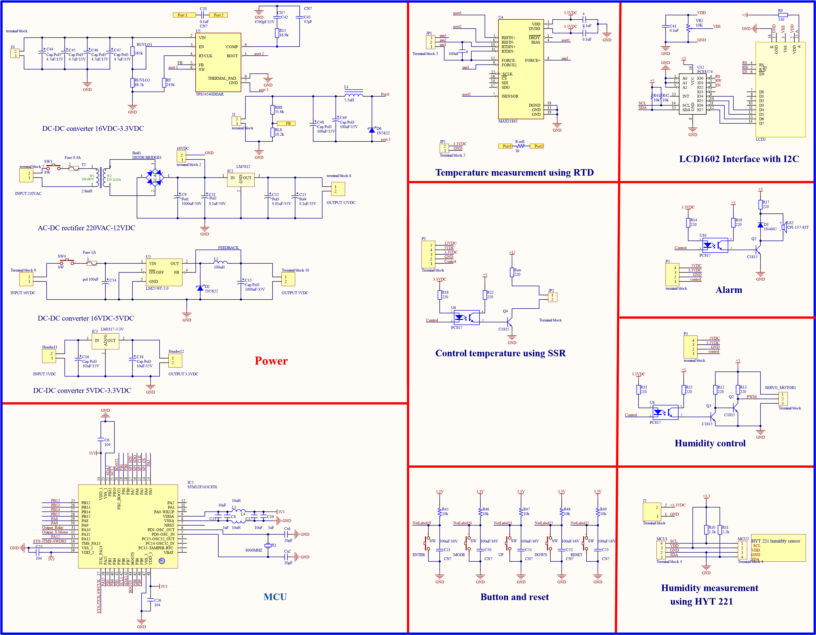

.

**PART 3: SOFTWARE DESIGN**

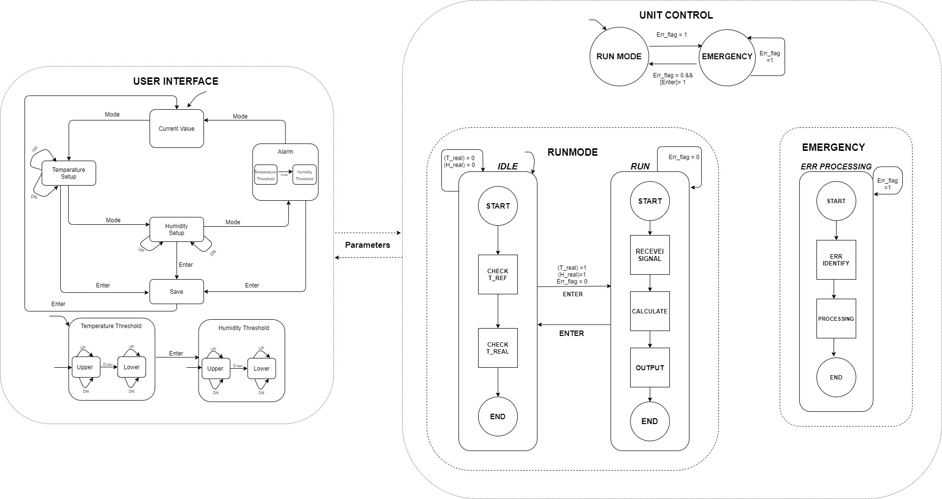

*Figure 13: General finite state machine*

**3.1. Finite state model of user interface**

* User interface provides the functions of the current operational parameter display or the adjustment of working parameters namely desired temperature, desired humidity, minimum and maximum temperature as well as that of humidity.

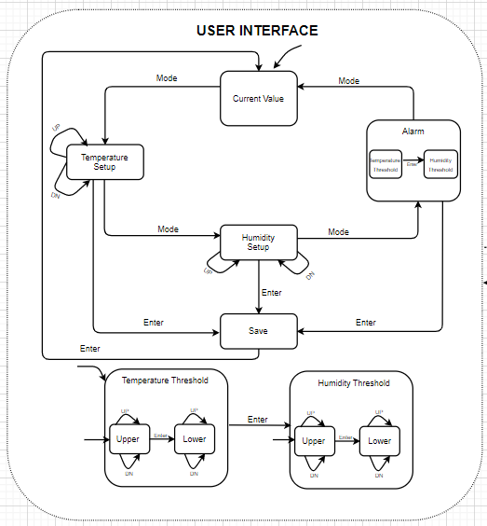

*Figure 14: Finite State Machine for user interface*

For the most convenient experiences for users, the system is added with 4 buttons, which are Mode, Enter, Up, Down. When the electric power sources supplied to the system, the initial state (Current Value) will be automatically shown up with the value of current measured temperature and measured humidity. Pressing the Mode button to change the content display to either Temperature Setup, Humidity Setup or Alarm.

In Temperature Setup mode and Humidity Setup mode, users can adjust the desired value by press Up or Down button. Next, press Mode to change to another State, or press Enter to send the new set value to unit control to process.

In Alarm mode, we have two substates consist of Temperature Threshold mode and Humidity Threshold mode. In each substate, we have mode to adjust upper and lower threshold for both temperature and humidity. Up, Down buttons are used with the same functions as mentioned above. Enter button is used to change between substates.

**3.2. Finite state model of controller**

Controller provides the functions of heating up the atmosphere by generating PWM signal and opening range of valve by control actuator servo motor. There are 2 main states: Run Mode and Emergency.

*Figure 15 : Finite State Machine for unit control*

In Run Mode, we have 2 substates Idle and Run. The Idle mode is activated when the first time the system connected to power source.

If measured temperature and humidity in this state greater than 38 degree Celsius and 85% respectively, T_real and H_real equal to 0 and the system remained this state no matter efforts to start the machine. If the measured value smaller than that standard and Enter button is clicked, run mode is activated.

In Run, measured values and set value are received and controller will calculate to achieve the set value. If the measured values excess the desired value, controller will minimalize the power provide to the actuator and wait for it to cool down. In this state, there are several cases in which temperature and humidity will rise( such as systematic malfunction, suspicious pressure raising leading to temperature increase, … ), the Emergency mode will be activated. In his state, the system will identify error and process it . Until error flag back to 0 and Enter button is pressed, the system back to the Run mode.

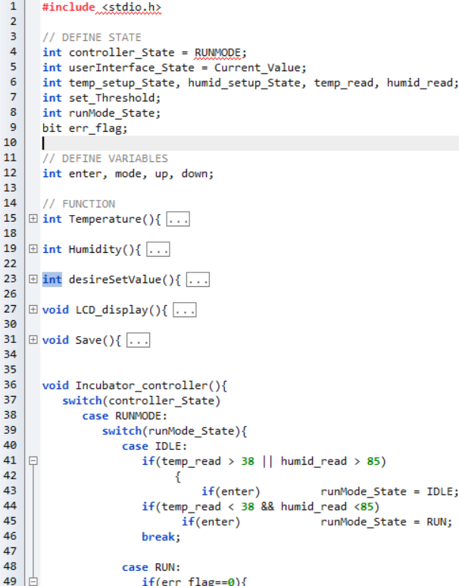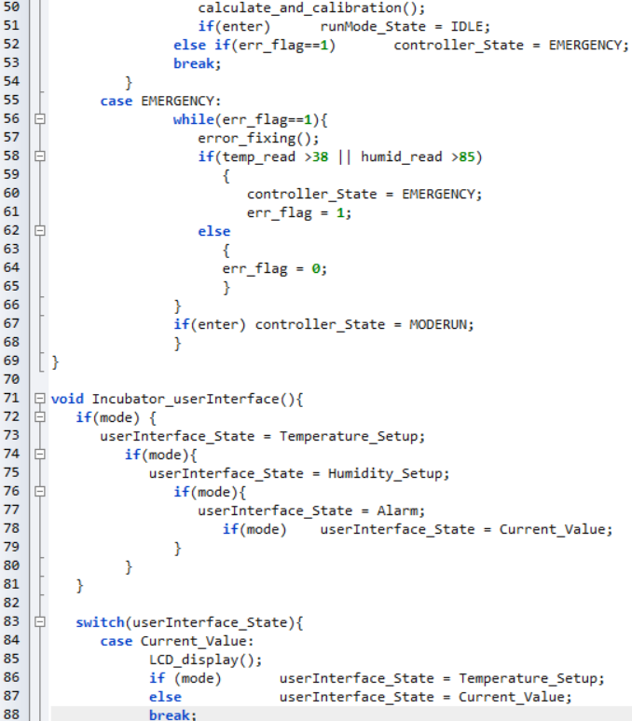**3.3. Sequential Program Model**

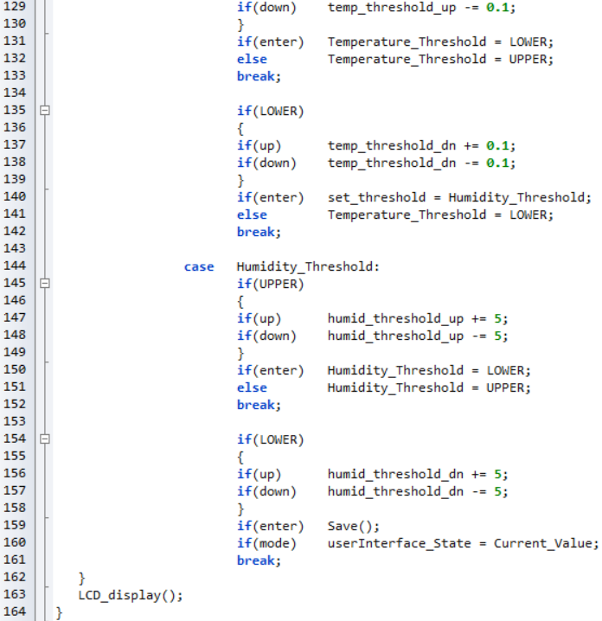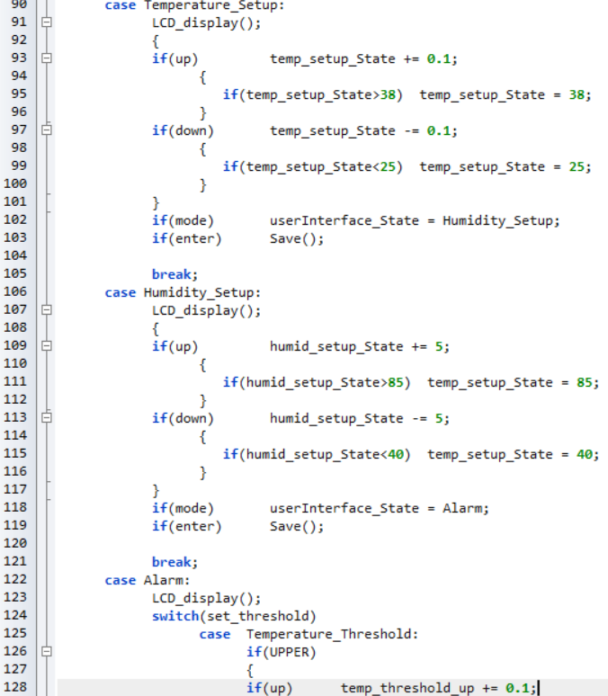

**REFERENCES**

1. “Intelligent baby incubator” by Megha Koli, Purvi Ladge, Bhavpriya Prasad, Ronak Boria, Prof. Nazahat J. Balur

2. “Temperature monitoring system for infant incubator using Arduino” by N.A.A Hadi, M.H. C Hasan, NMZ Hashim, N.R. Modhmmad, A.S. Rahimi, K.A. Annvar

3. “Multivariable IMC- PID within air-conditioned room temperature and relative humidity control system” by ZENG Xiaochen, YU Chunxuan

4. “Optocoupler as Optical Isolator for SPI Bus System” by Dimitrij Martins and Achim M. Kruck

5. “Optical Isolator for I2C Bus System” by Dimitrij Martins and Achim M. Kruck

6. Datasheet of components